API Endpoint

🌐 What is an API Endpoint
# Source: AI Source: Provided by: [Data Path: Persons Table -> ID Column: 1, Name_En Column: Motasem Essam] -> From: [ChatGPT] on [1/19/2026]
An API Endpoint (also called API Routes) is a specific URL or URI where an API client can access a resource or perform an operation.
👉 Think of it as the “address” where your API does its job. Each endpoint represents a function or a resource in the API.

🔑 Key Points About API Endpoints
# Source: AI Source: Provided by: [Data Path: Persons Table -> ID Column: 1, Name_En Column: Motasem Essam] -> From: [ChatGPT] on [1/19/2026]
- Represents a resource or action
  - Examples of resources: users, orders, products
  - Each endpoint typically corresponds to a specific operation on that resource
- Uses HTTP methods to indicate action

Method | Meaning
GET | Retrieve data
POST | Create a new resource
PUT | Update an existing resource
DELETE | Remove a resource
PATCH | Partial update of a resource
- Returns structured data
  - Usually in JSON or XML format

🧱 Example: API Endpoints for a User Resource
# Source: AI Source: Provided by: [Data Path: Persons Table -> ID Column: 1, Name_En Column: Motasem Essam] -> From: [ChatGPT] on [1/19/2026]
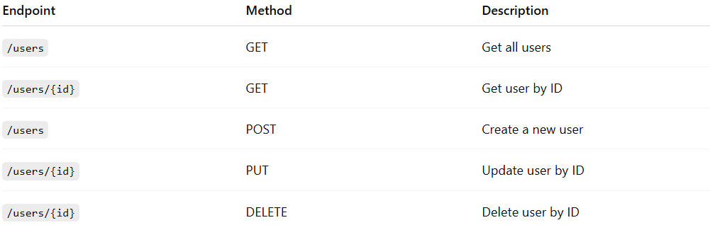
Endpoint | Method | Description
/users | GET | Get all users
/users/{id} | GET | Get user by ID
/users | POST | Create a new user
/users/{id} | PUT | Update user by ID
/users/{id} | DELETE | Delete user by ID

🔄 Real Example (Spring Boot, Java)
# Source: AI Source: Provided by: [Data Path: Persons Table -> ID Column: 1, Name_En Column: Motasem Essam] -> From: [ChatGPT] on [1/19/2026]
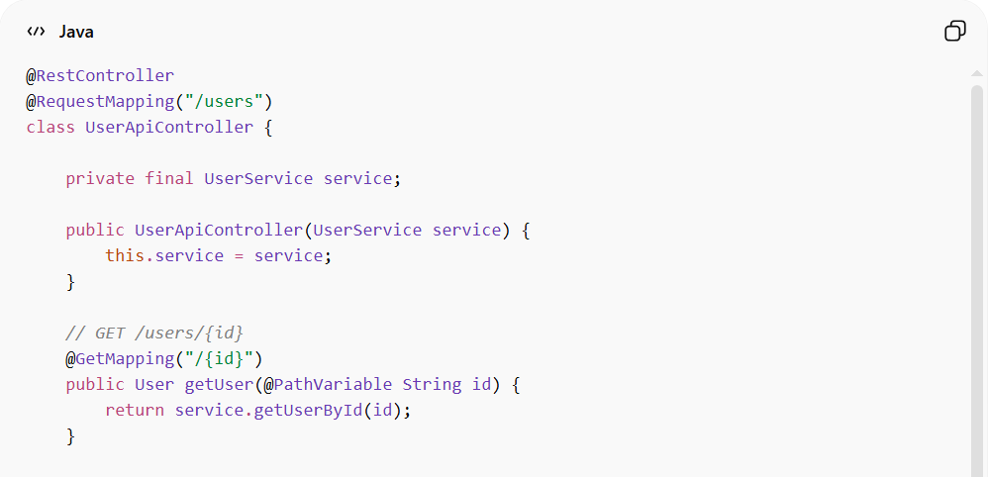
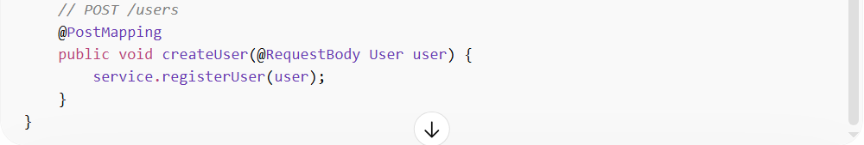
@RestController
@RequestMapping("/users")
class UserApiController {

private final UserService service;

public UserApiController(UserService service) {
this.service = service;
}

// GET /users/{id}
@GetMapping("/{id}")
public User getUser(@PathVariable String id) {
return service.getUserById(id);
}

// POST /users
@PostMapping
public void createUser(@RequestBody User user) {
service.registerUser(user);
}
}
- /users/{id} → API endpoint to get a user by ID
- /users → API endpoint to create a new user

💡 Analogy
# Source: AI Source: Provided by: [Data Path: Persons Table -> ID Column: 1, Name_En Column: Motasem Essam] -> From: [ChatGPT] on [1/19/2026]
If your API is a restaurant, an endpoint is like a specific menu item. You send a request (order) and get a response (your food).

⚠️ Key Points
# Source: AI Source: Provided by: [Data Path: Persons Table -> ID Column: 1, Name_En Column: Motasem Essam] -> From: [ChatGPT] on [1/19/2026]
- Each endpoint should have a single responsibility
- Keep endpoints RESTful and predictable
- Return appropriate HTTP status codes for success/failure

